

Memorandum No: Businessjournal/2023/07/23

To

**The Managing Director,**

Asia Pacific General Insurance Co. Ltd.

Dhaka.

**Subject:** Regarding giving PSI ads.

Dear Sir,

We are happy to inform you that **'Businessjournal24.com'** entered the 6th year as the economic news portal of the country since April 2018. The purpose of running **'Businessjournal24.com'** is to spread the information about capital expansion and development of capital markets and all the information about capital investment in the capital market, easily reaching the common investors and concerned. Already, **'Businessjournal24.com'** won the mind of millions of investors and readers through quality news coverage. Not only share market, the journal has received wide readership of our country's by providing renowned economists interviews and current world markets, economics, politics, sports, entertainment and international news. Every day, countless readers of various classes and occupations are visiting our website.

In order to co-operate with this initiative, we will encourage you to publish all your organization's enterprise, products or price sensitive information as advertisement.

**Thanks in advance**

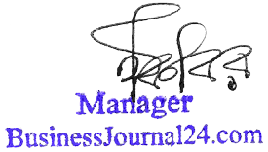

Manger (Advertisement)

**Advertising Price List**

|  |  |  |
| --- | --- | --- |
| **Price Sensitive Information** | **Place of Advertisement** | **Price** |
| Homepage | TK. 10,000/= |